Creating the PS4 Adaptive controller

Table of contents

1. Introduction 2

2. Bill of materials (BOM) 3

3. Preparations 4

3.1 Dissasemble the controller 4

3.2 De-solder the joysticks 11

4. Assembly 13

4.1 Placing and fastening 3.5mm sockets 13

4.2 Screw pcb to pcb holder 13

4.3 Soldering the speaker 14

4.4 Screwing the pcb holder to the case 15

4.5 Soldering the buttons to sockets 15

4.6 Place and connect usb port module 41

4.7 Secure the battery 42

5. Testing 43

6. Troubleshooting 45

# Introduction

The PS4 Adaptive controller is designed to be used by people with a physical limitation. The modular designs allows the buttons and joysticks (we call them ‚modules‘) to be placed as the user needs them.

By making it open source we allow the community to come up with their own designs and share them with others.

The skillset required to create your own controller is kept as low as possible to allow the creation of as much controllers as possible: Knowledge of using a soldering iron, access to and knowledge of a 3D printer and a laser cutter (optional), and the use of some basic tools like a wire stripper are the only things needed. We try to provide as much information as we can on how to create your own controller.

If you have any questions you can contact me at [kefcom@hotmail.com](mailto:kefcom@hotmail.com)

Have fun creating and using the ps4 adaptive controller,

Kevin E. (-kefcom-)

# Bill of materials (BOM)

The list of materials needed to create a ps4 adaptive controller and a link to where to buy them are listed in [Bill_Of_Materials.txt](https://github.com/kefcom/ps4adaptive/blob/master/controller/controller%20c1931/Bill_Of_Materials.txt).

We keep it central so people can modify it when needed.

If a link is dead contact me at [kefcom@hotmail.com](mailto:kefcom@hotmail.com) and I’ll try to provide a new link.

# Preparations

## Print and/or laser cut the models

3D print the PCB holder model and print or laser cut the front and back plate.

## Disassemble the controller

This is where the real work begins :).

At the back of the controller there are 4 screws, unscrew them.

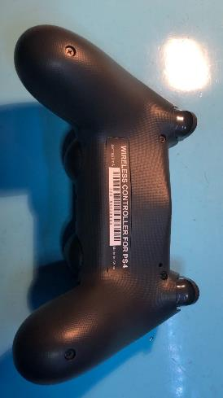

Now open the shell, but be careful of the flex cable from the usb port to the pcb!

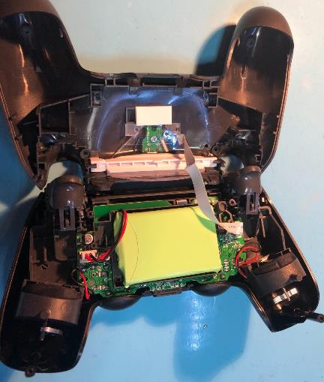

Gently unplug the cable on the PCB side and put the top shell away for now.

Disconnect the battery and remove it. The plastic holder can be removed as well.

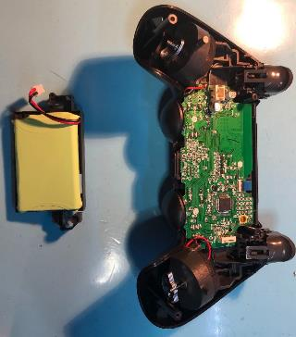

De-solder the vibrators left and right (the red and black wires)

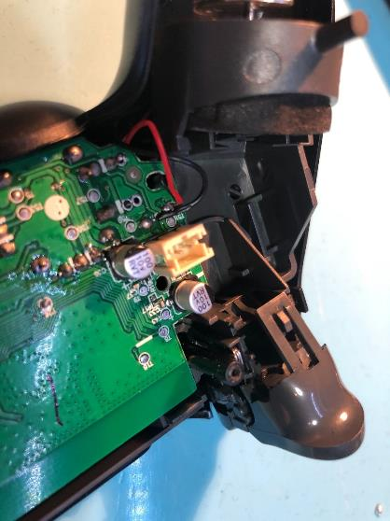

Unplug the touchpad flex (lift the black tab and unplug the cable)

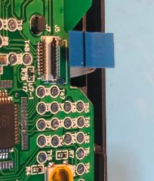

Remove the screw in the center

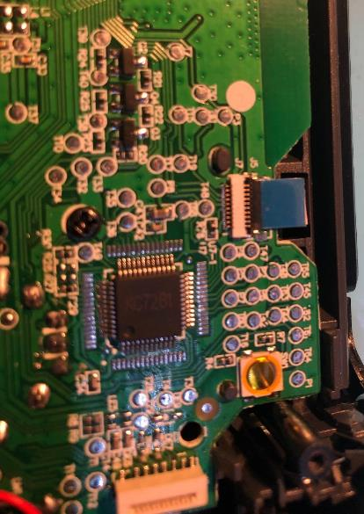

Now remove the middle assembly and remove the pcb.

You should end up with the pcb with the joysticks

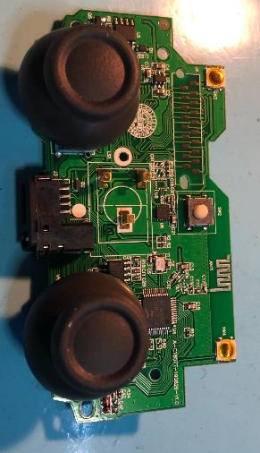

Now take the shell with the usb port

Lift the white bar holding the plastics in place and remove the plastics

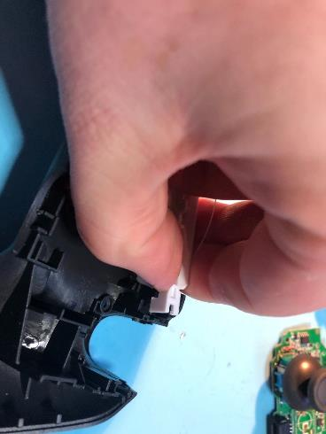

Remove the screw holding the usb port in place and remove the usb port

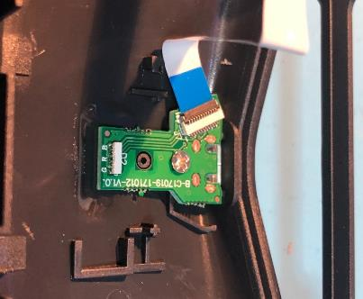

You should end up with a usb port assembly:

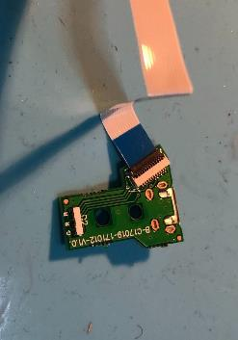

Now for some cleanup of the rest of the shell. These components are re-used in some modules, so take them if you want to create the speaker and d-pad module

Remove the d-pad pad and plastic

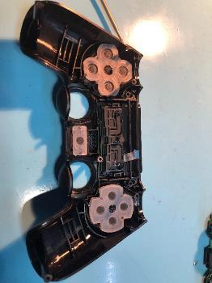

To remove the speaker, **gently** push from the front. It’s glued in place

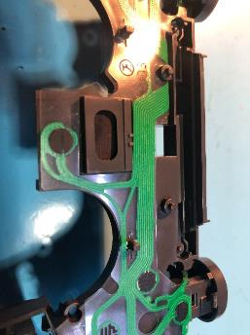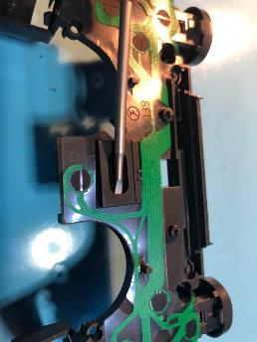

This concludes the cleanup and disassembly of the controller.

## De-solder the joysticks

**Be very careful in this step! If you flex the board too much or over heat it, the controller can break and become useless.**

First remove the joystick tops, these can be pulled off.

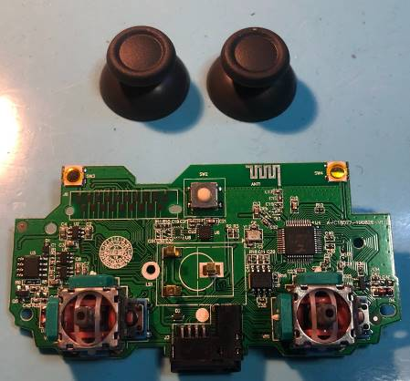

Then pry the potentiometers from the joysticks and de-solder them first

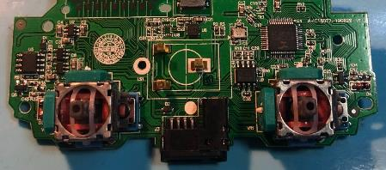

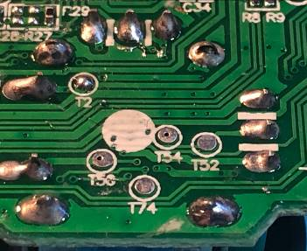

After the potmeters are gone you can start to work on the joysticks themselves

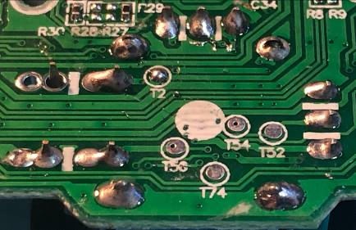

What I found what works for me is to use a small screwdriver and stick it between the pcb and the joystick, please keep in mind to be gentle and not put too much force when prying.

This concludes the prep work, next step: assembly!

# Assembly

## Placing and fastening 3.5mm sockets

Place the 24 sockets in the front plate and secure them with the provided nuts.

When finished, flatten all ground pins (the top ones) for easy access later.

## Screw pcb to pcb holder

Place the pcb on the pcb holder, with the headset port facing down, then screw the pcb to the holder as seen in the image

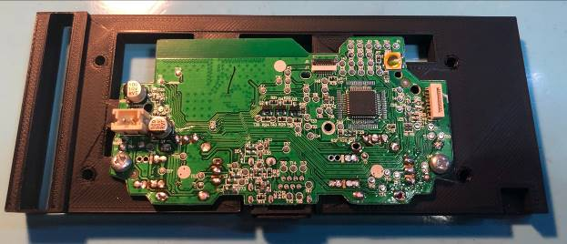

## Soldering the speaker

Before we screw the pcb holder to the case, we need to solder the speaker. Use the following schematic to solder the speaker to the socket.

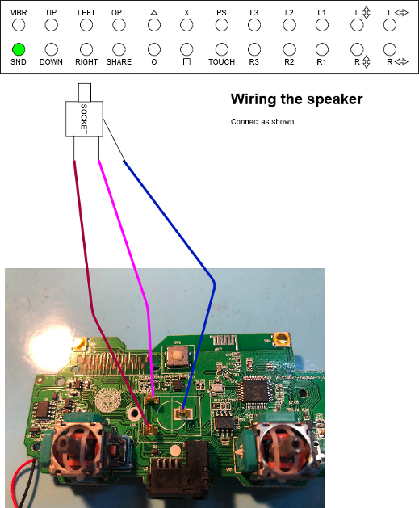

## Screwing the pcb holder to the case

Allign the 4 pre-made holes in the pcb holder to the case and screw the pcb holder to the case.

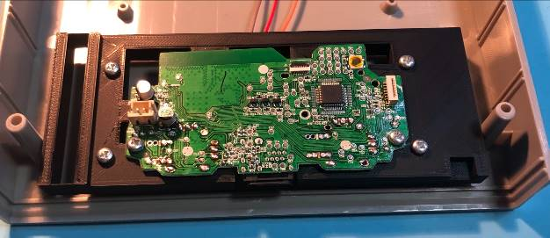

## Soldering the buttons to sockets

Time to solder all the things!

Use the schematics to solder the buttons to the sockets.

### Create a shared ground plane

Because all the buttons (except L2 and R2) need to be connected to P1 on the pcb, we need to create a ground plane. To do this solder all the top pins (except VIBR,SND,L2,R2 and the 4 joystick sockets) together via 1 wire and connect that 1 wire to pad P1 on the pcb.

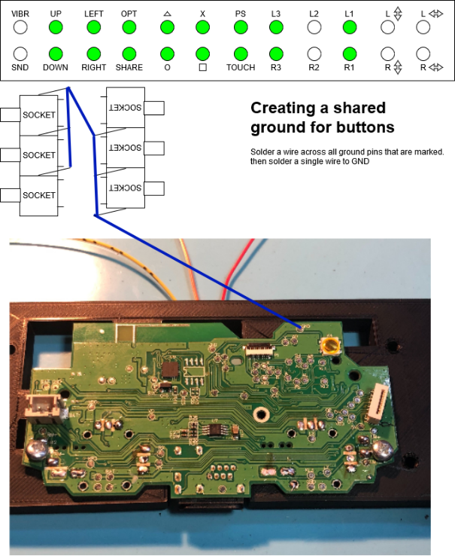

### Create a shared VCC for L2 and R2

Same as for the shared ground, but for VCC (pad P3 on the pcb) L2 and R2 need VCC instead of GND.

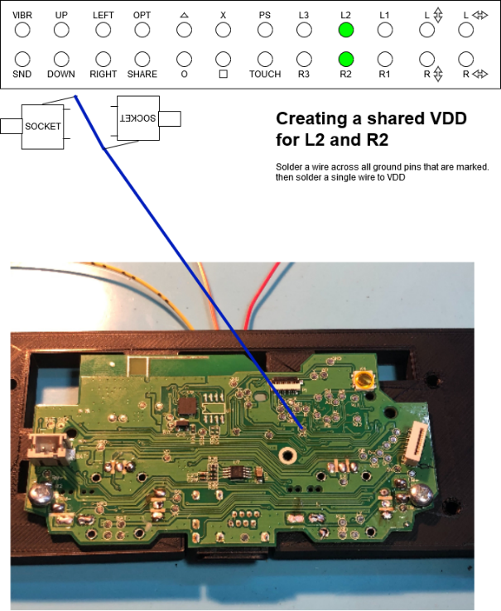

### Soldering the vibrator

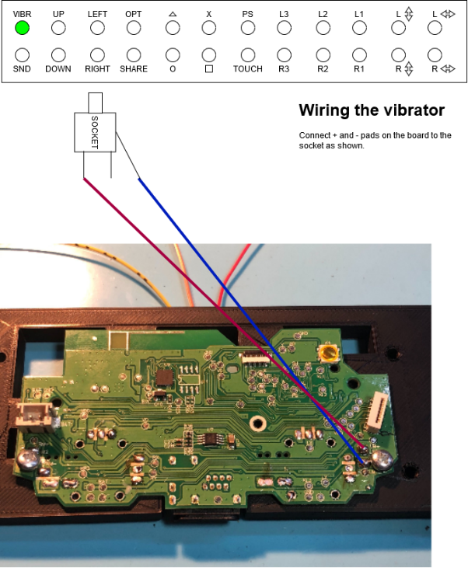

### Soldering the ‘up’ D-pad button

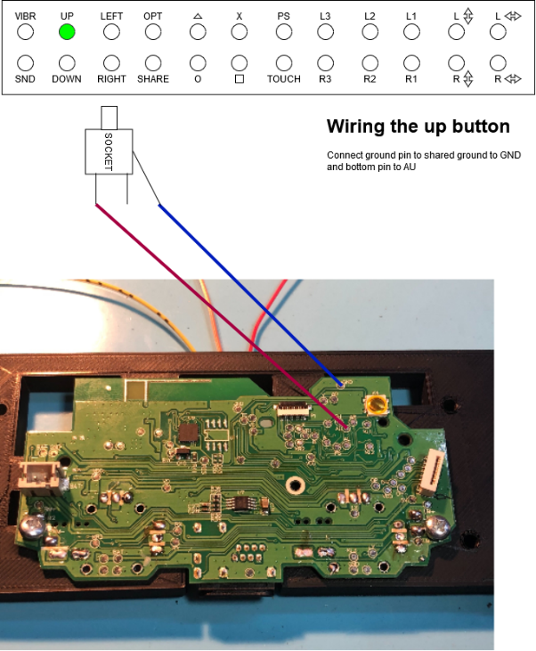

### Soldering the ‘left’ D-pad button

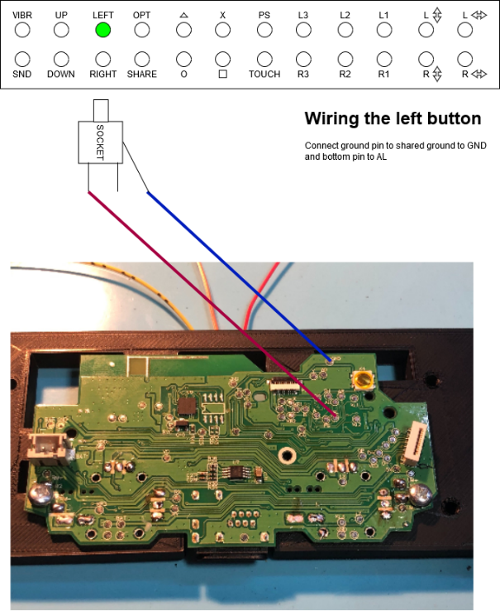

### Soldering the options button

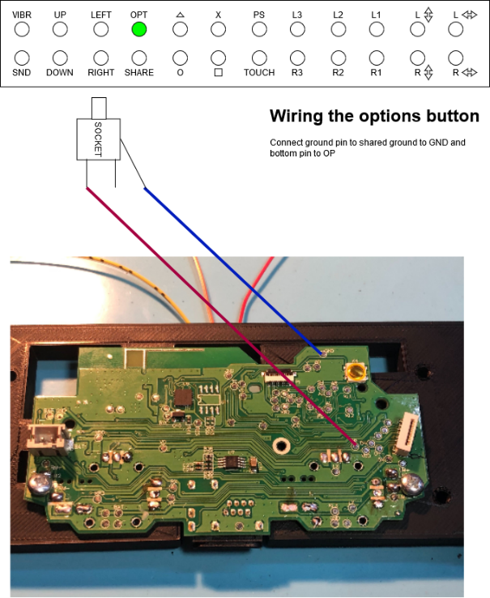

### Soldering the triangle button

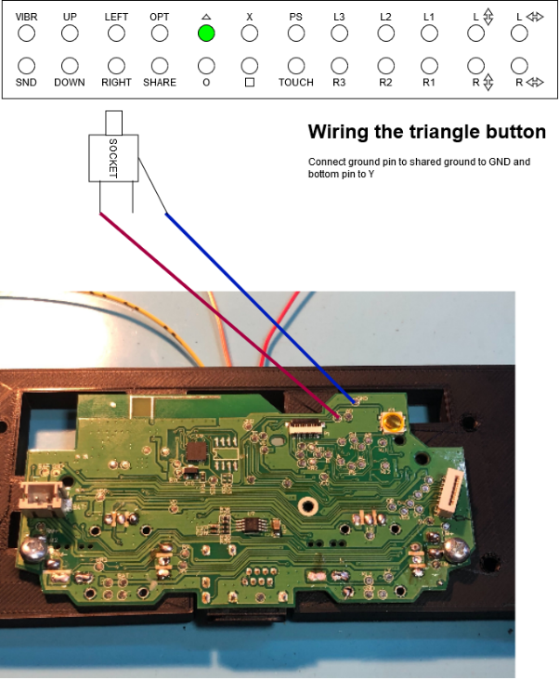

### Soldering the X button

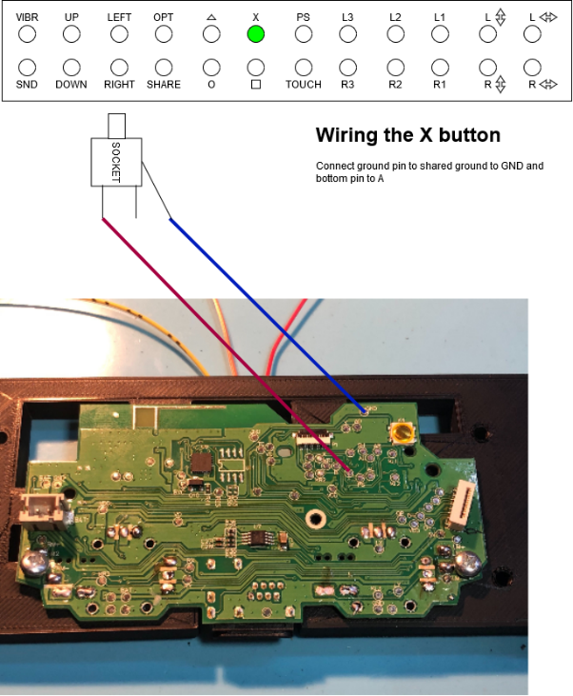

### Soldering the PS button

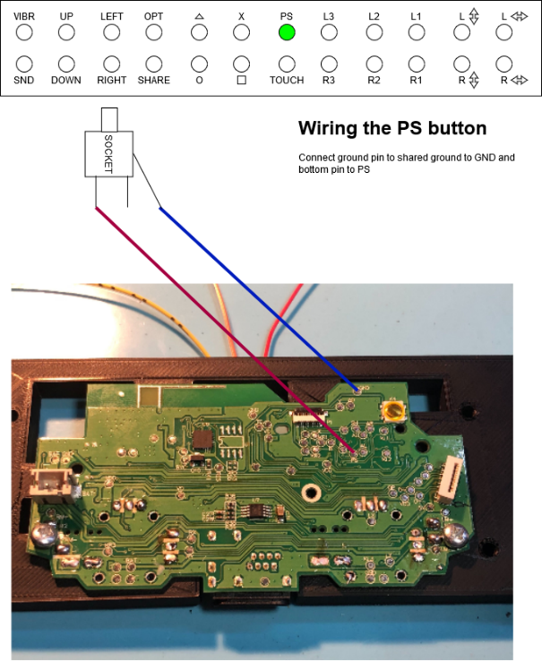

### Soldering the L3 button

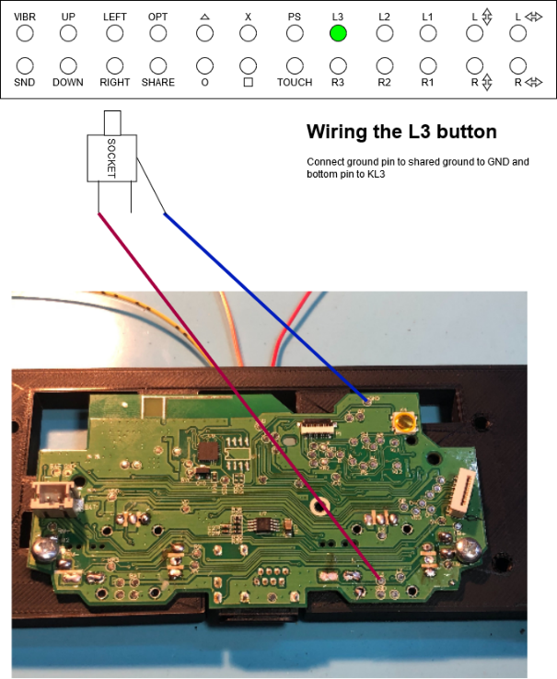

### Soldering the L2 button

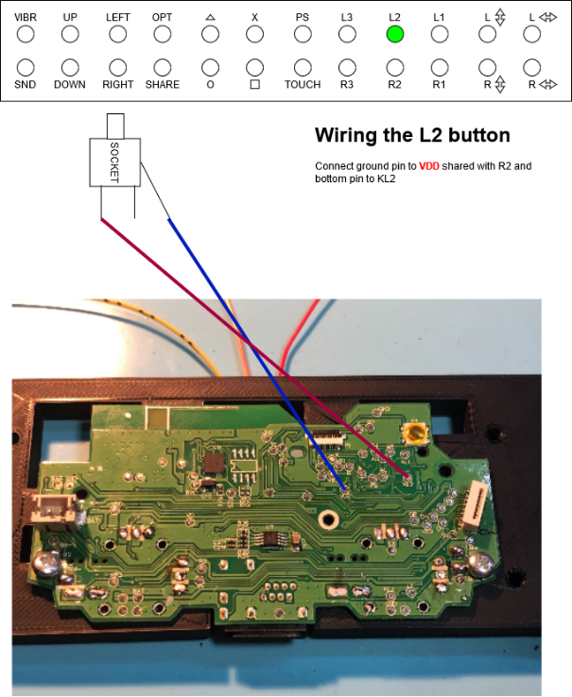

### Soldering the L1 button

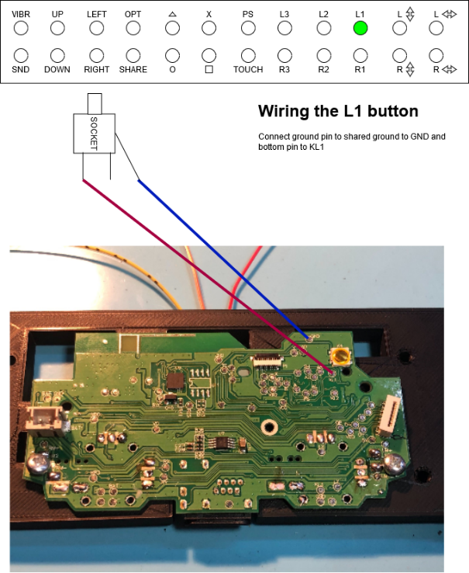

### Soldering the left joystick (up/down)

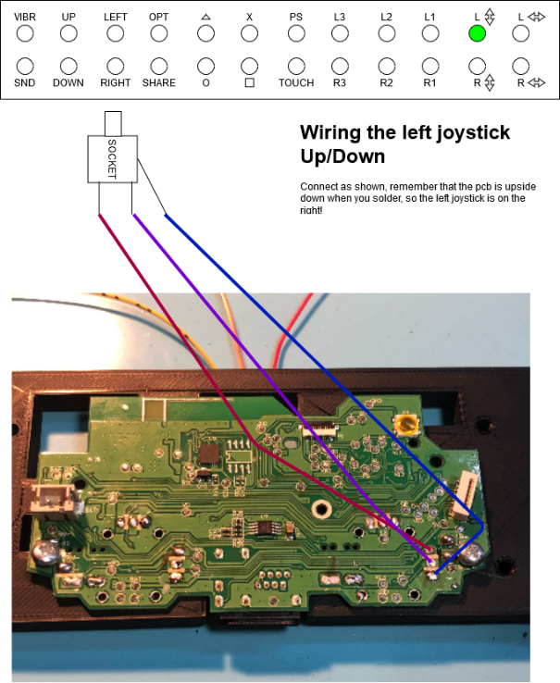

### Soldering the left joystick (left/right)

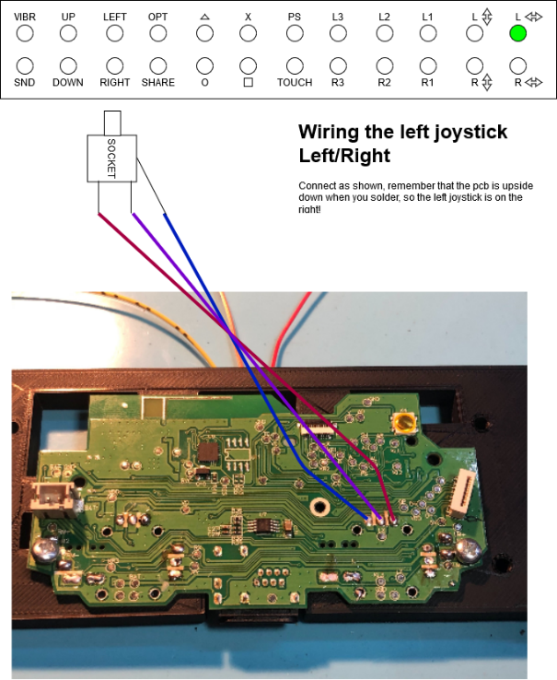

### Soldering the ‘down’ d-pad button

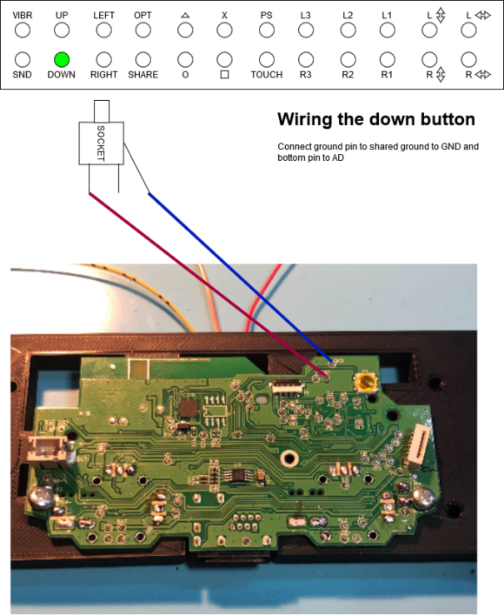

### Soldering the ‘right’ d-pad button

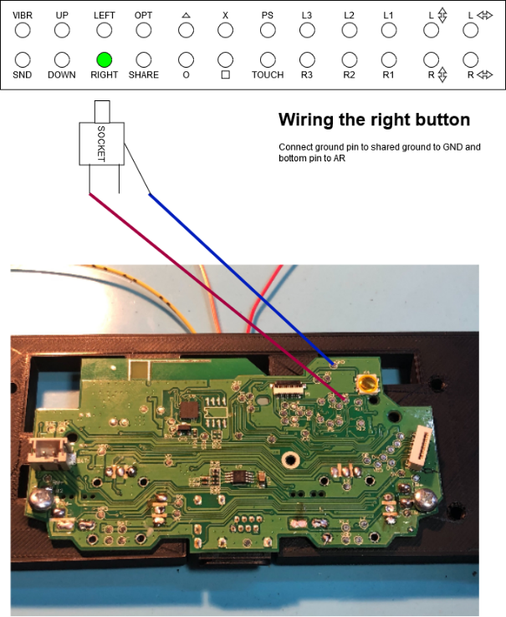

### Soldering the share button

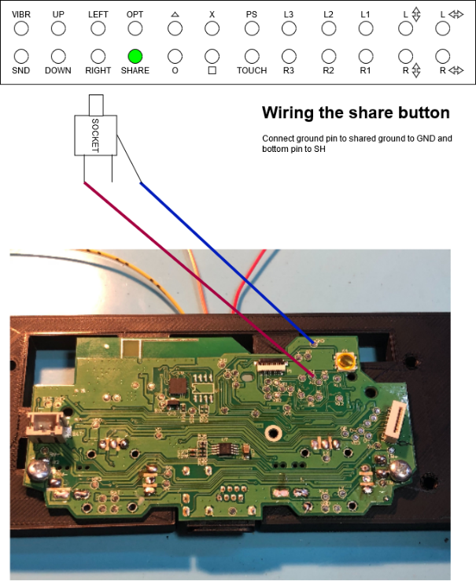

### Soldering the circle button

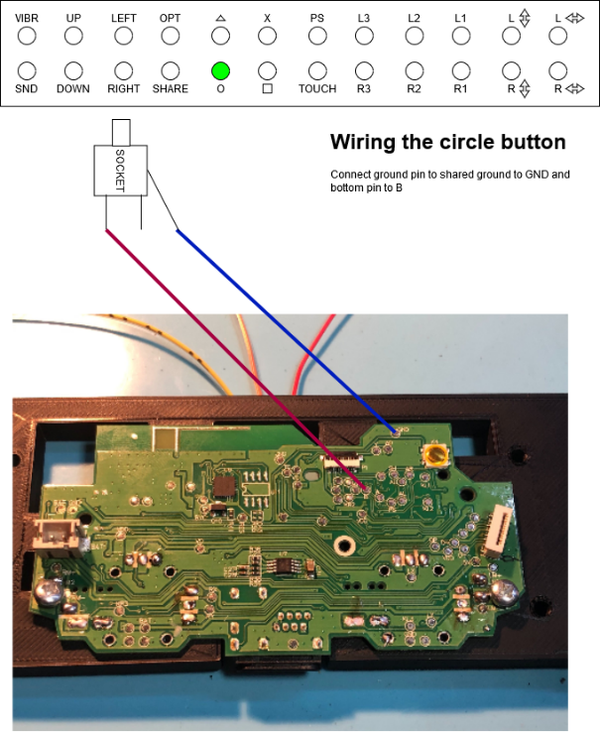

### Soldering the square button

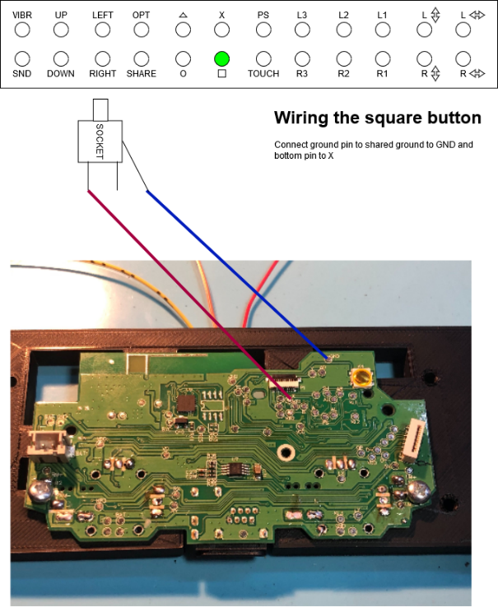

### Soldering the touch button

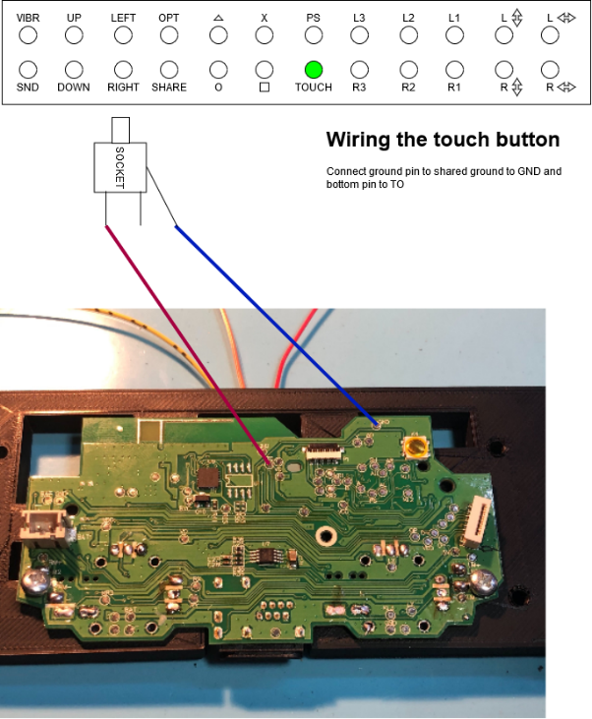

### Soldering the R3 button

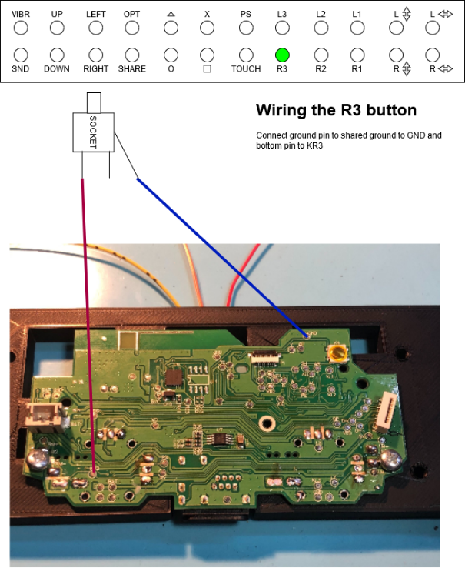

### Soldering the R2 button

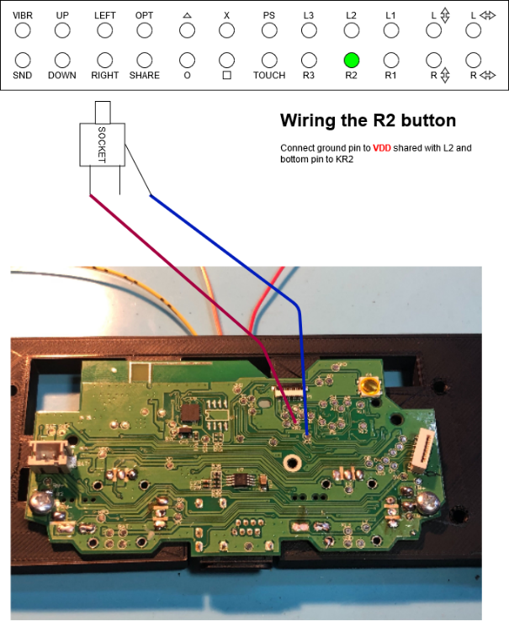

### Soldering the R1 button

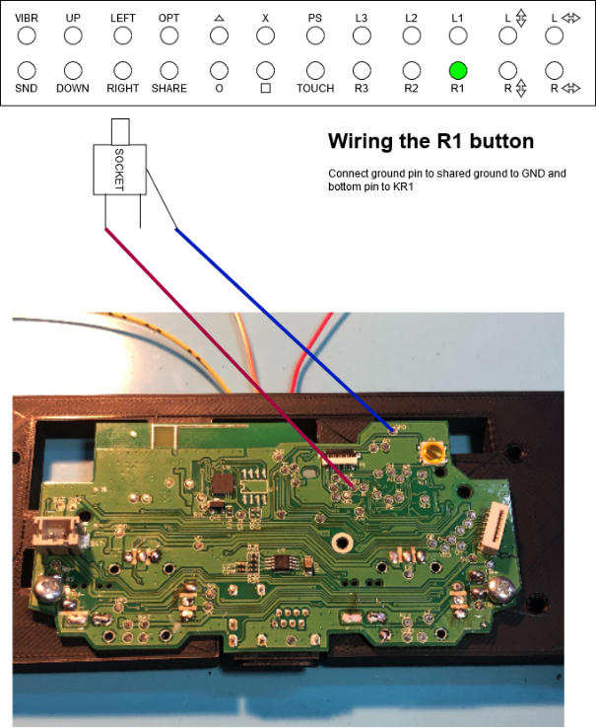

### Soldering the right joystick (up/down)

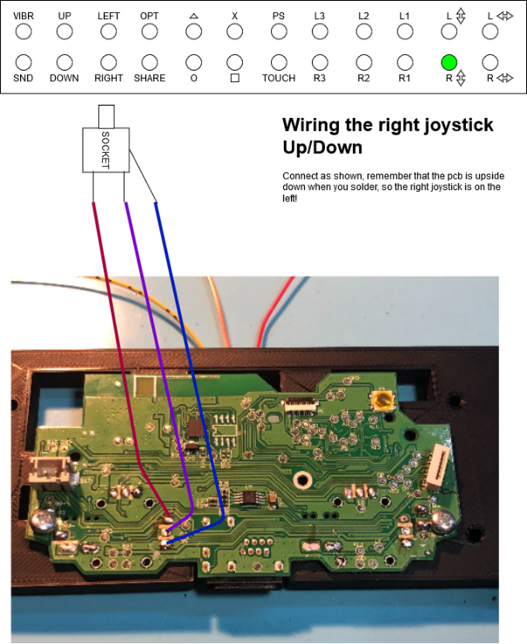

### Soldering the right joystick (left/right)

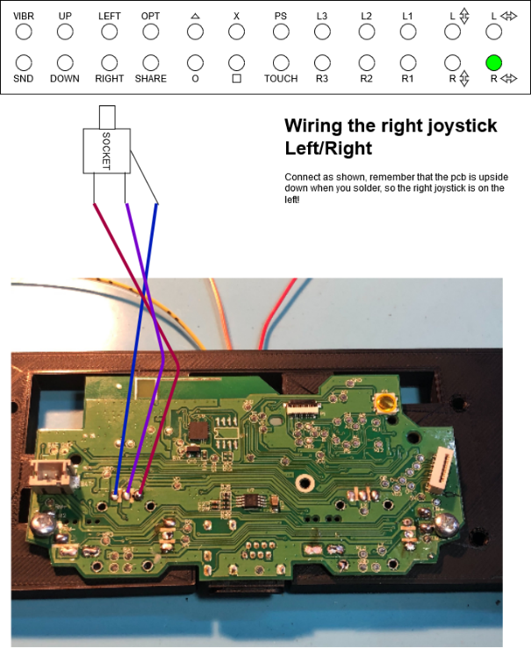

## Place and connect usb port module

Place the USB module in the provided slot and use a screw to secure it to the pcb holder.

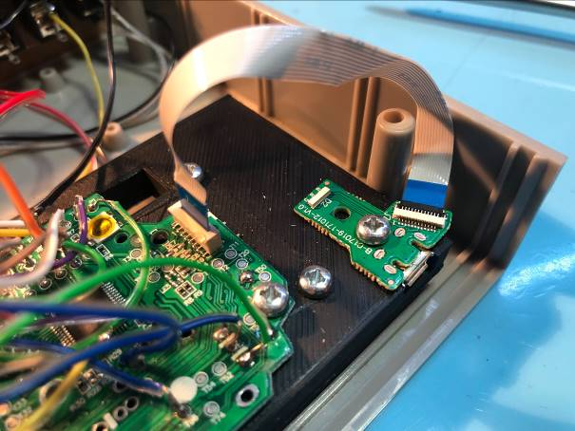

## Secure the battery

Use some putty adhesive (blue tack / stuff to put posters up on your wall) around the bottom of the battery to secure it in the provided slot.

Connect the battery to the PCB.

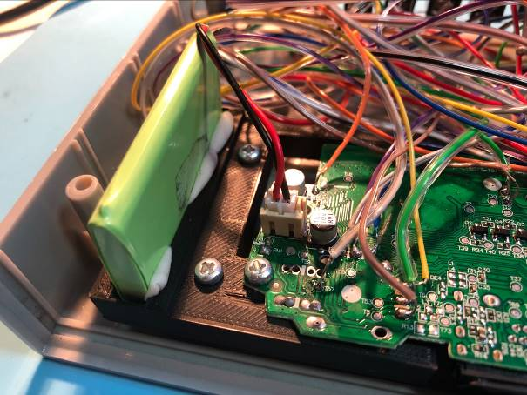

# Testing

Now comes the time to test, to perform a test you need 2 joysticks and at least 1 button.

Connect the 2 joysticks

Connect the controller via usb to a windows pc (if you don’t have one, I propose you test directly on the ps4)

Open the control panel and go to hardware and sound -> devices and printers -> find your controller (‘wireless controller’), right click and select game controller settings.

A new window will open, select properties.

A new window will open:

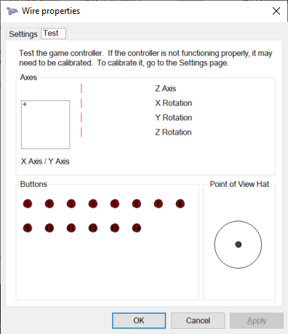

Here you can test the controller, make sure the joysticks work (in this image there are no joysticks connected, the crosshair should be in the middle and the Z axis and rotation should show half a bar.

Use the following mapping to test your buttons. The number of the pressed button should light up

|  |  |
| --- | --- |
| Button | Number |
|  |  |
| Up | Point of view Hat |
| Down | Point of view Hat |
| Options | 10 |
| Triangle | 4 |
| X | 2 |
| PS | 13 |
| L3 | 11 |
| L2 | 7 |
| L1 | 5 |
| Down | Point of view Hat |
| Right | Point of view Hat |
| Share | 9 |
| Circle | 3 |
| Square | 1 |
| Touch | 14 |
| R3 | 12 |
| R2 | 8 |
| R1 | 6 |

If all works, you’re good to go!

Place the back plate and close the case using the provided screws and feet.

Remember that just like a normal controller you need to connect the ps4 adaptive controller to the PS4 via usb before you can use it wirelessly.

# Troubleshooting

Here are a few troubleshooting tips:

|  |  |
| --- | --- |
| Problem | Suggested solution |
|  |  |
| No connection | Make sure the USB port flex cable is plugged in with the blue marker facing left. |
| No connection | Try to test with joysticks attached, sometimes the pcb does not work if no joysticks are connected. |
| Joysticks not working (or behaving strange) | Make sure you wired it as shown in the schematic. The joysticks have to be wired exact. |
| Connection lost when pressing L2/R2 | You might have connected them to ground instead of VCC. Make sure the top pin of the socket goes to P3 instead of P1 |
| Pressing 1 button triggers 2 or more | You might have a short somewhere, check cables to see if the copper touches |